**WEB DESIGN**

**PROJECT REPORT**

**PROJECT TEAM**

|  |  |
| --- | --- |
| **Student number** | **Student Names** |
| 20149298 | Colm Regan |
| 20157568 | Marek Augustyn |
| 20119330 | Adam Kennedy |

**NCI Chess Society**

[**https://test.marekaugustyn.whshost.com**](https://test.marekaugustyn.whshost.com)

[**http://ncichesssociety.gearhostpreview.com**](http://ncichesssociety.gearhostpreview.com)

**Overview – Executive Summary**

NCI Chess society is a Chess club located in the library of the National College of Ireland.

The main goal of the website is to provide a one stop shop for club members and Chess lovers, where they can get the latest information about upcoming club tournaments, beginner friendly training and the latest news and updates from the world of Chess. The site also offers free membership for all chess lovers as well as a newsletter sign up option where they can be sent weekly updates and tips on improving their Chess strategies and tactics.

We decided on this idea because we felt that it would be of great benefit to have a Chess club at NCI. Chess is a thought provoking and mentally stimulating game, which is absolutely perfect for students. According to Stanborough 2020, playing chess increases one's memory and intelligence and also elevates creativity. By forming a Chess club at NCI we are creating a social hub, where people of similar interests can get together and form relationships while also stimulating their minds with the intellectual challenge that playing chess provides. Bringing the great game of Chess to NCI allows students to improve the health of their mind while also forming connections. This addresses many issues that are known to be prevalent across the education system. According to aldersons broaddus university 2020, the most common issues for college students is social anxiety, depression, lack of energy or motivation, hopelessness, being overwhelmed, low self-esteem and loneliness.

Having a Chess club at NCI addresses a number of the above issues, it will tackle loneliness as it allows students and people alike to make friends, whilst also increasing their cognitive functioning. Chess also is a great way to improve planning skills and may equip certain students to get a foothold on their current assignments or upcoming exams which in turn would tackle issues like lack of motivation, hopelessness and feelings of being overwhelmed.

Another great thing about the NCI Chess club is that it is not limited to NCI students, it is open to all staff members and members of the public. Chess is for everyone and everyone should be able to benefit from it regardless of circumstance.

**Section 1: Design**

We looked at a number of different chess websites during our research for this project. 3 such sites were:

**Dublin Chess Club**

This is oldest chess club in Ireland (founded in 1867) and is located at the United Arts Club at 3, Upper Fitzwilliam St., Dublin 2. This website is also aimed towards chess lovers but with a wider scope. What we liked about this site is the large header. This really caught the eye when we first discovered this website. However, we felt that the logo of this site left a lot to be desired. We also liked how this website has the navigation list above the logo. From research of this site, we decided that we would have a large logo at the top of all pages of our website with the navigation list just above it. We agreed to make this list with a static position to reduce the necessity for scrolling up and down.

**The Chess Website**

This was a great website from which we gathered a lot of ideas. This is an informative website for all chess lovers and is not based on an existing Chess club. However, although our website is aimed at members of a chess club, it also provides information and training on the game of chess. We found similarities between our site and this site and noticed that the informative piece of the Chess Website follows the F design pattern. We also decided to adopt this pattern for the informative areas of our website. According to Mialki 2020, The F design pattern is the way our eyes move when we read content online, scanning the page in this order:

First, across the top of the page to read important headlines

Then, down the left side of the page to view numerals or bullet points

Lastly, across the page again to read bolded text or sub-headlines

We decided to incorporate this pattern with our own twist.

**The Rathmines Chess Club**

This is one of Dublin’s oldest, biggest, and most successful chess clubs. This website is similar to ours as it is also aimed at members of a Chess club. What we liked about this page is how the all the information is contained neatly. At the beginning of our research, we decided to adopted this approach and wrapped all of our content in a container, only filling 90% of the horizontal width of the page. In the end we decided to abandon the container in favor of the full width of the screen being used. This was easier when it came to incorporating Bootstrap and the responsive aspects of the site.

We took inspiration from the ‘Roll of Honor’ section of this website and decided to incorporate our own Honor Role. We used the members of the group project for the first 3 entries and filled the rest of the leaderboard with some of the greatest players to ever play the game. We swapped the first letters of the first and surnames so as to not directly use their names. We thought this would be a nice tribute to these wonderful Chess players.

## Requirements & Technical Approach

When we set out to make this website, we knew it was going to be informative. From the outset we knew would need to incorporate a design pattern that would be suitable for informative websites. The F design pattern turned out to be perfect for our project, however this pattern is usually incorporated when the developer has a lot of content to show, whereas for our website, it was decided to limit the site to 5 pages of HTML. For this reason, we decided for the left-hand side of the page, rather than the traditional bullet points and links you would traditionally see with the F design pattern, to just have images while the middle and right columns would be reserved for information. It was our own take on this very popular and effective design pattern.

## Sitemap & Wireframe

**Page 1 Home Page site map**

This was our initial plan for the homepage. However, this highlighted some difficulties when we tried to make it responsive. We also had difficulties getting appropriate images with the correct size to fit into the page. We also didn’t like how the user had to scroll back up to the top of the page when they wanted to navigate to another section.

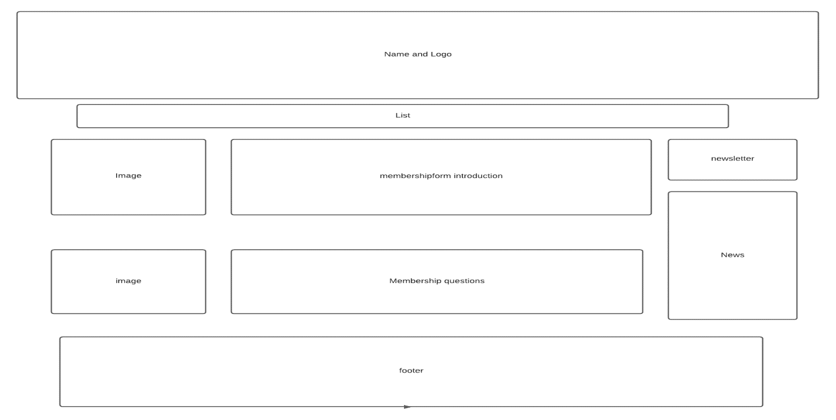

After a review of the above highlighted difficulties, we decided to redo our plan of the homepage. We incorporated a layout provided by the Bootstrap framework which took care of the responsiveness of our web page. We also decided that we would have all the images rotating in the center of the page. By rotating the images in this way, we were able to create more space on the page for our content. In order to limit the amount of scrolling the user had to do to navigate the site, we implemented a navigation menu with a fixed position. This way the menu always stayed at the top of the users screen so that all they had to do was move the mouse the top of their screen rather than scroll back to the top of the page.

This was our final homepage wireframe.

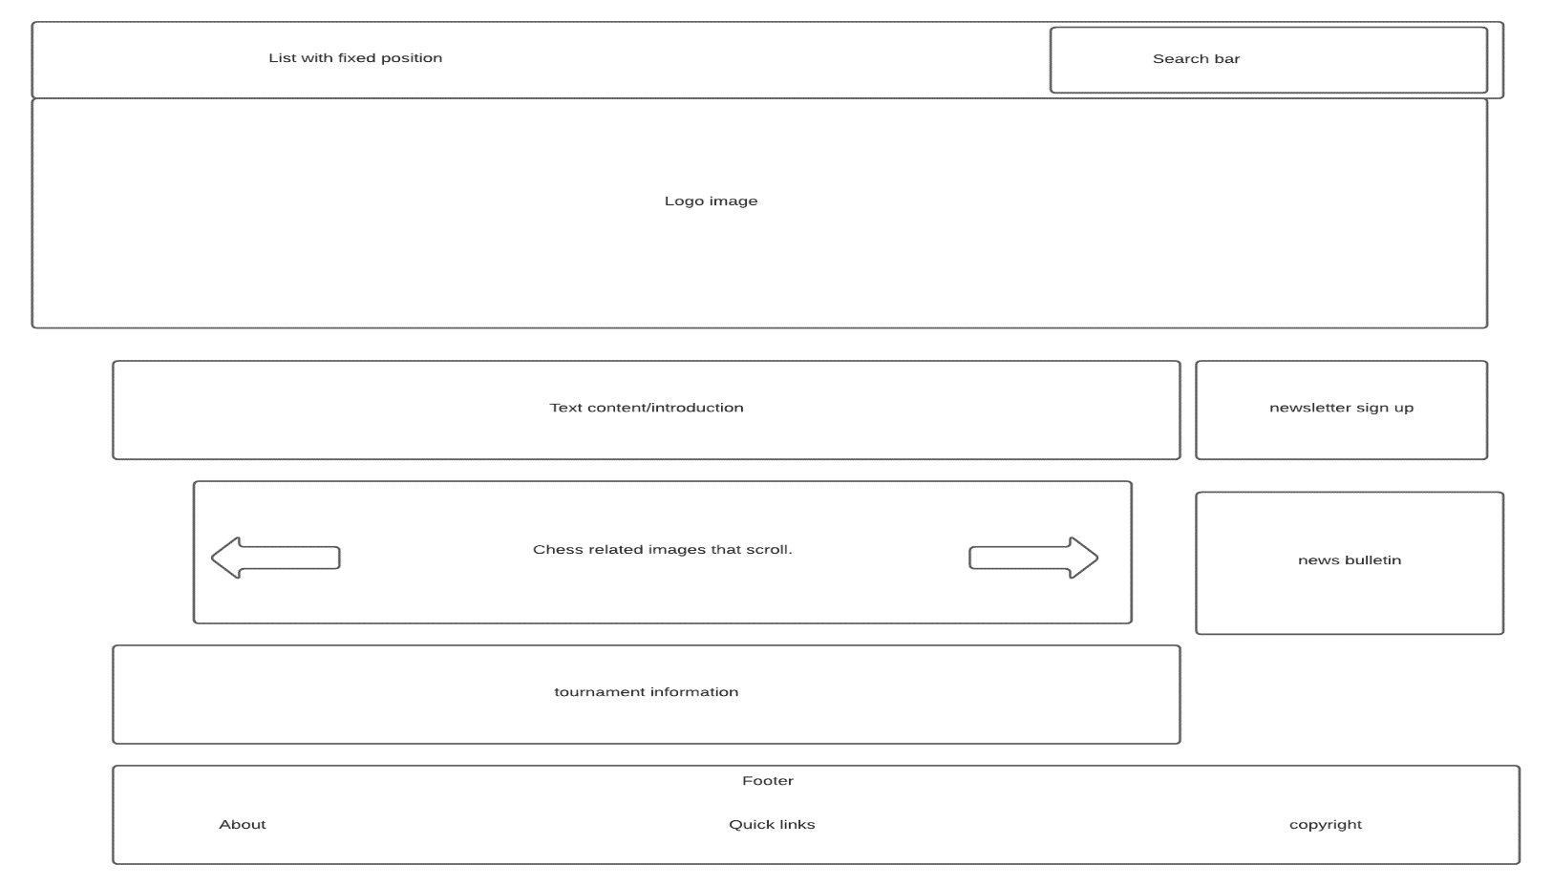

**Page 2 site map**

Page 2 was our About section. We decided that this page would follow our initial homepage layout whilst incorporating the same header and footer as our new homepage, so that each page could be consistent. Below is our final page 2 sitemap.

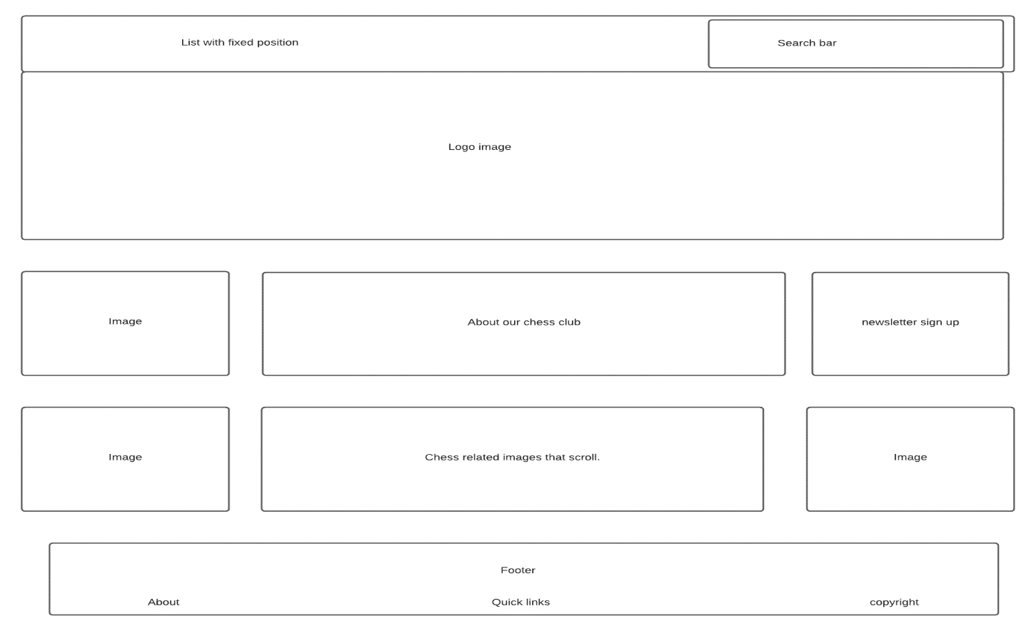

Page 3 site map

Page 3 was our training section. We decided to separate the middle content of the page into beginner, intermediate and advanced sections. Underneath this section we decided to place links to helpful YouTube videos. On the left is a link to a beginner friendly video, while on the right is a link to a more advanced level video.

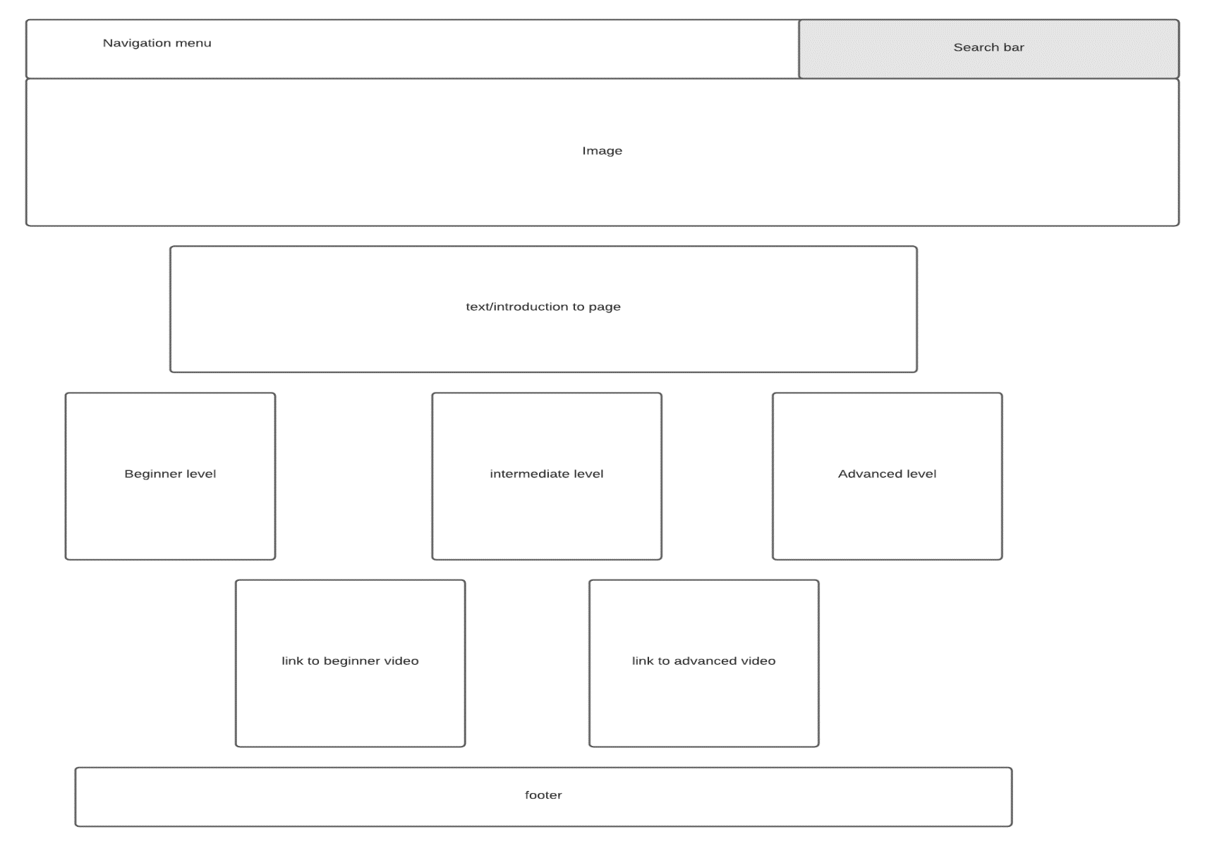

Page 4 – membership form site map

This was our initial plan for the membership page, where validation errors appear between two images just to the left of the form. This presented some difficulties and we struggled to find appropriate images. It also followed our old layout.

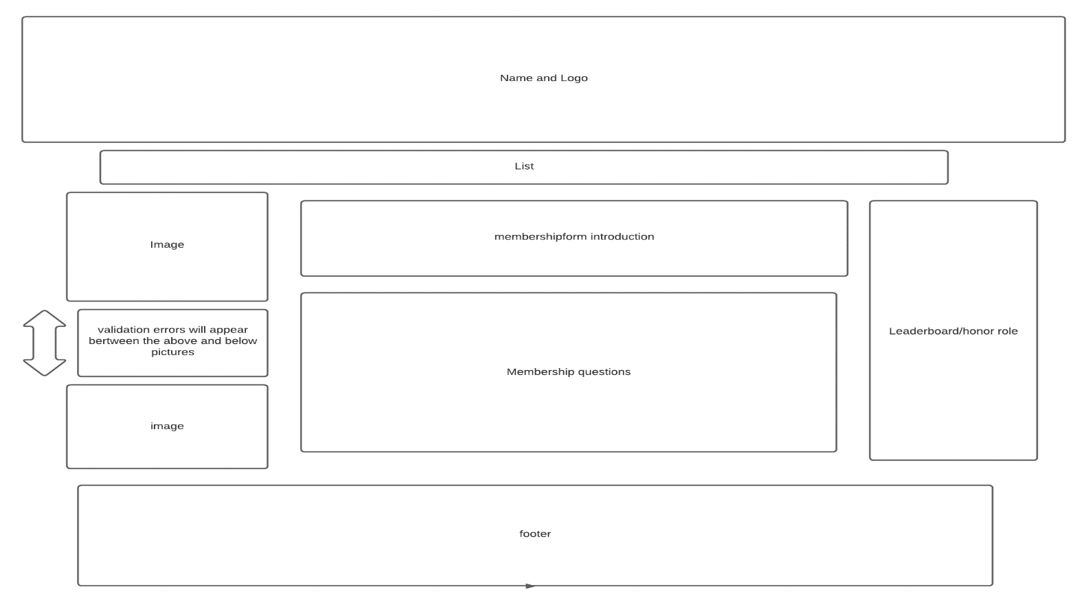

We had to update this page based on the above difficulties. Below is our final wireframe for this page.

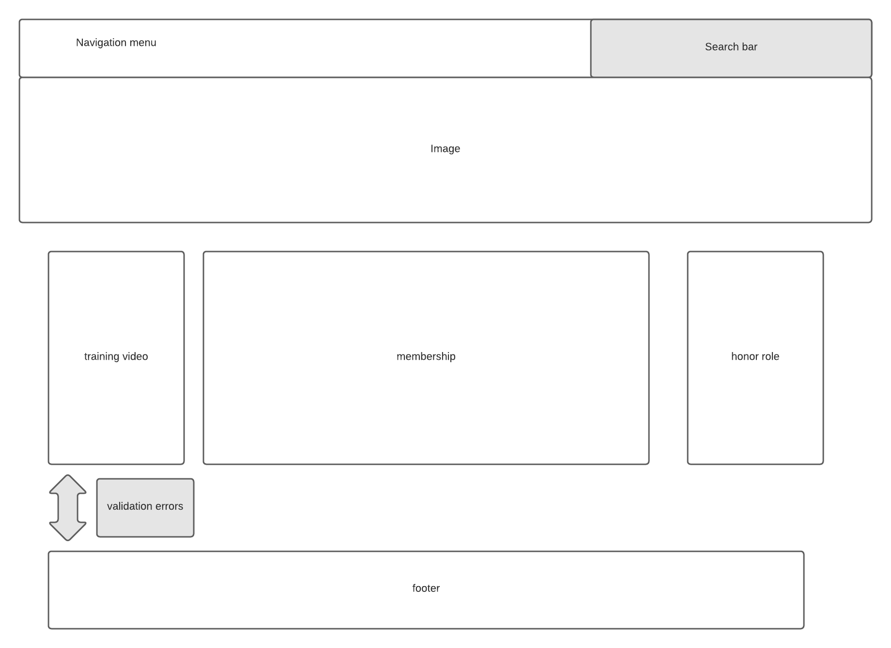

Website Wireframe

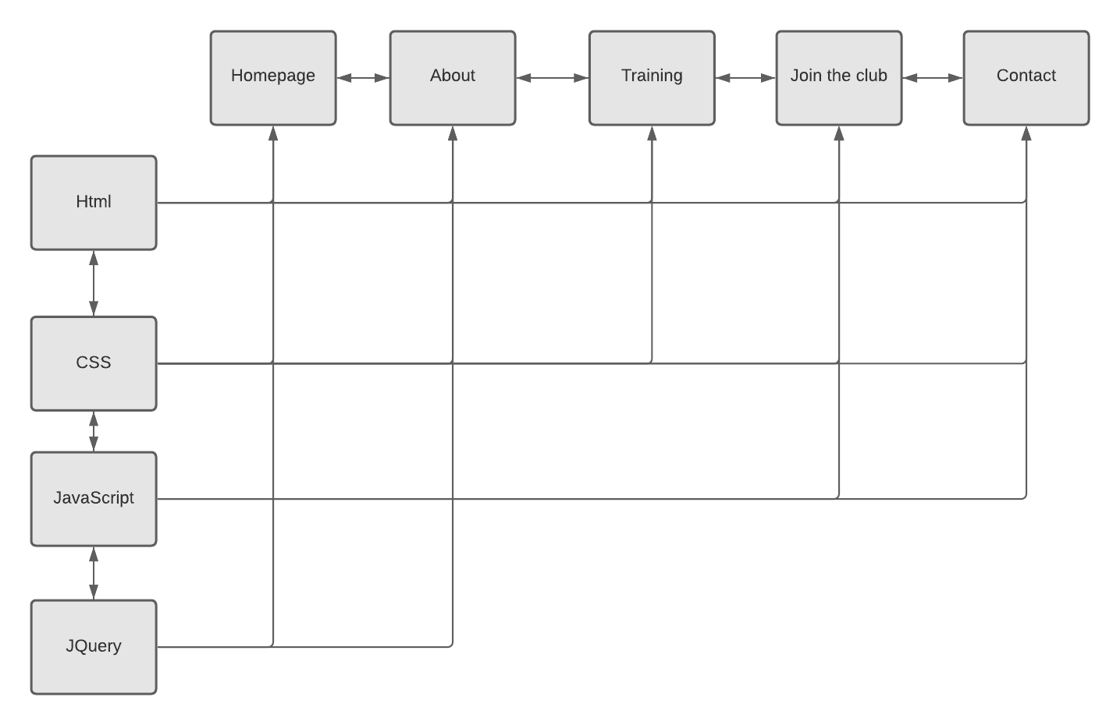

**Persona interviews.**

**Interview 1**

1. How old are you?

29

1. How would you rate your Chess skills on a scale from 1-10?

Probably around a 5, I know how to play Chess but I would know too much about strategy and tactics.

1. Are you a student at NCI?

Yes

1. How often would you play Chess?

Maybe once or twice a year.

1. What is your current level of education?

I am a student of Social Care.

1. How would you rate your computer expertise on a scale of 1 to 10?

Not great, probably a 3 or 4.

1. Would you join a Chess club?

No

1. If not, why not?

I am too busy with my studies and I wouldn’t be good enough to compete.

1. Would you be interested in improving your abilities in Chess, if it could improve your overall focus and cognitive skills?

Yes. I am overwhelmed with assignments and exam preparations, if playing chess could help in any way I would play more.

1. What is it about Chess that makes you want to play?

Nothing really, I learned how to play when I was young, I believe it was at a summer camp. Its too much work for me, having to remember all the different ways each piece can move and plan a strategic attack on your opponent when he/she makes a certain move, its all just very unappealing to me.

1. What words would you use to describe your social status?

Its pretty good. I like to go out (not this year) and hang out with friends 3 or 4 times a week.

**Interview 2**

1. How old are you?

33.

1. How would you rate your Chess skills on a scale from 1-10?

I play Chess quite a bit, I would say maybe 7 or 8.

1. Are you a student at NCI?

Yes.

1. How often would you play Chess?

I would probably play once a week with a friend of mine, or sometimes against the computer when I am bored.

1. What is your current level of education?

I am a student of computer science.

1. How would you rate your computer expertise on a scale of 1 to 10?

Probably 9 or 10.

1. Would you join a Chess club?

Yes. I would join a chess club if it could provide some extra benefit for me.

1. If not, why not?

Well to be honest, I wouldn’t have the time, however if the club also hosted tournaments and provided training I would definitely join so that I could up my game and maybe win some prizes.

1. Would you be interested in improving your abilities in Chess, if it could improve your overall focus and cognitive skills?

Yes. Definitely.

1. What is it about Chess that makes you want to play?

Well, I like to solve puzzles and think strategically. I like to discuss and experiment with different tactics.

1. Is this the reason you decided to study computers?

Yes, definitely. I like to use my mind and think logically about certain problems.

1. What words would you use to describe your social status?

Well, I don’t really go out a lot. Im not a fan of night clubs and don’t necessarily like to drink much alcohol. I have many friends but I don’t really see them much. They would all be introverts like myself.

**Interview 3**

1. How old are you?

25

1. How would you rate your Chess skills on a scale from 1-10?

I am very interested in the game of Chess, I know how to play but would love to get better. I would say my skills range between 5 and 6.

1. Are you a student at NCI?

No.

1. How often would you play Chess?

I have a Lichess account on my smartphone. I play against the computer sometimes but I can never win.

1. What is your current level of education?

I am graduate of Computer Science from Trinity College.

1. How would you rate your computer expertise on a scale of 1 to 10?

10.

1. Would you join a Chess club?

Yes. I would join a chess club if It could make me a better player.

1. If not, why not?

Timewise, it could be a bit of a burden but if there were other services offered by the chess club such as live training and tournaments it would be worth it.

1. Would you be interested in improving your abilities in Chess, if it could improve your overall focus and cognitive skills?

Yes. As a programmer, I need to stay focus for many hours during the day, if playing chess could improve this ability, I would definitely play more.

1. What is it about Chess that makes you want to play?

I like the variations. I love how each piece can move in completely different ways and that you have to strategize in order to figure out what is the best piece to move in this current scenario. There are many ways of attacking but figuring out the best way is what I love.

1. Is this the reason you decided to study computers?

Yes. I have always love maths and I love to understand complicated things.

1. What words would you use to describe your social status?

I go out most weekends with friends but most of the time we would go to see a movie or have dinner. Nothing too crazy. I don’t drink alcohol and like to exercise.

From evaluation of these interviews, we gathered that 2 out 3 of our interviewees like to play Chess and also studied computers. We also discovered that there may be some correlations between playing Chess and working with computers, in terms of mental stimulation and required focus. By conducting these interviews, we gathered that our primary persona would not just be introverted intellectuals but really anyone who may have background in engineering or other computer related disciplines, regardless of their current social status.

We targeted our site towards introverted people who like to keep to themselves but also towards people who enjoyed socializing. We also discovered that in order to attract Chess players to our club, we must provide more than just a meet up group where people play Chess. From this research, we decided that we would host tournaments and provide on sight training for those who want to improve their Chess game. It was also clear to us from this research that not many people are aware of the great benefits that playing Chess provides. We wanted to tackle this issue by providing people with Chess related news and information from the world of Chess in the form of a weekly newsletter. In the newsletter we would talk about how good Chess is for the brain and how beneficial it can be to people of all backgrounds and ethnicities. We also decided to have a news bulletin which would provide information and news updates from the world of Chess so that people could get a better understanding of just how popular the game of Chess really is and how many people around the world play it on a daily basis.

**Our Primary Persona**

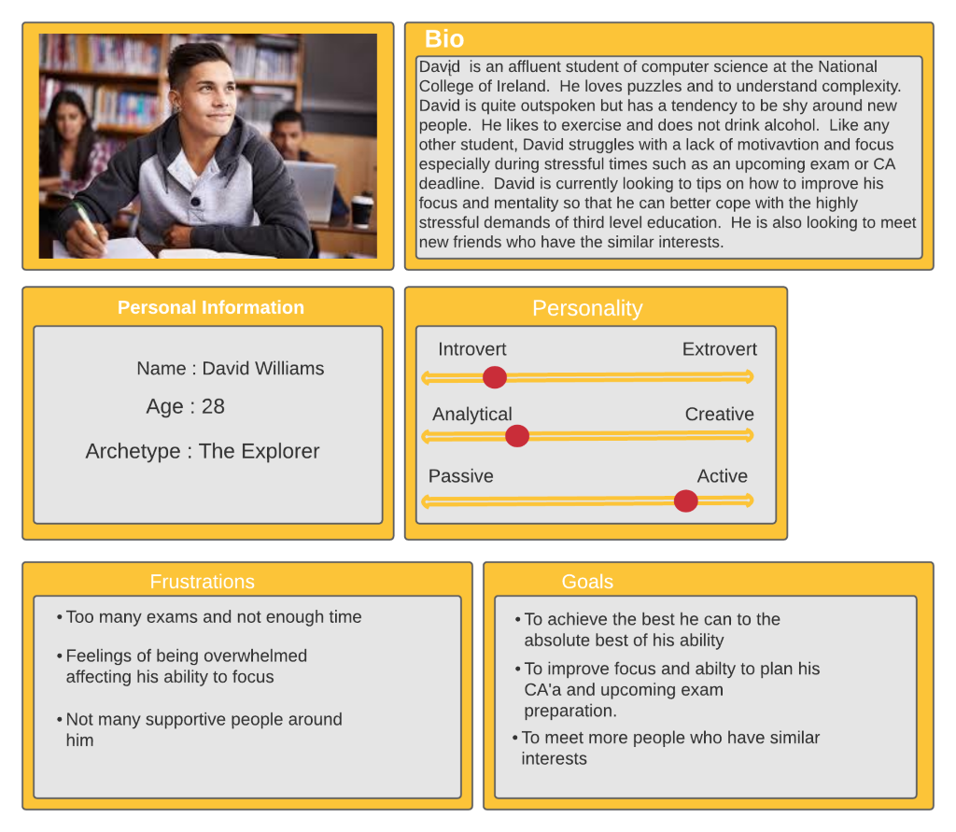

**Section 2: Development**

This website was made using HTML5, CSS, Javascript and a small bit of JQuery. Initially, we had planned on a basic structure with a navigational list under a large logo with content underneath. We had decided that each page would follow this structure. There was no issues regarding HTML and CSS for our initial plan. However, making the entire website responsive proved to be quite a technical hurdle. After many different attempts at rectifying the issue, we eventually decided to redesign the structure of the website and incorporated Bootstrap to help us with the responsiveness of our website. Our homepage and About page were put together with HTML and incorporates a small bit of JQuery. This was implemented to validate a person's email address when applying for the newsletter. Javascript was incorporated in our ‘Join the Club’ page as well as our Contact page in order to validate any errors in the membership for contact form.

**Code used from the web**

**1) Date Input**

We did a lot of research online during the development of this project. One such piece was inspired by the W3Schools website. See below.

**<td class="tableData"> DOB - DD/MM/YYYY<br> <input class ="membershipInput" id="DOB" type="date"/></td>**

This line of code allows the user to enter a date of birth. Initially we had this input type as text in which we specified the correct format to use i.e.. DD/MM/YYYY. However, when testing the project, this caused quite a bit of problems. Our solution was to research the W3Schools website and see if a user could enter an actual date using a calendar rather than text. Low and behold, we discovered that this was actually possible and we quickly implemented it into our project.

**2) Date Verification**

We decided that it would be a good example of form validation to only allow members over the age of 18. This involved validating the date of birth entered in the format above and returning false if the user is under 18. In order to achieve this we went back to W3Chools and discovered that there are JavaScript methods that allow you to get the exact date, month and year from a date input field. See below.

**var dt = new Date( DOBinput.value);**

**var today = new Date();**

**var age = today.getFullYear() - dt.getFullYear();**

The first line gets the date of birth entered by the user and stores it in a variable called dt through constructor injection.

The second line then gets todays date and stores it in a variable today. This line of code showed us that default constructors on the Date class use todays date.

Then in order to get the age year we simply subtracted the two years.

More validation was needed however. We developed the below code based on the following logic. if the current month was less than the month of birth, we subtract 1 from the persons age as they have an upcoming birthday this year. if the months are equal and the day is less than the day of birth, also subtract 1 from the age variable as they have an upcoming birthday this month.

**if (today.getMonth() < dt.getMonth() || (today.getMonth() == dt.getMonth() && today.getDate() < dt.getDate()))**

**{**

**age--;**

**}**

**Validation & Errors**

**HTML.**

Html on ours web pages was validated on the page <https://validator.w3.org>

Index.html had 8 errors like No space between attributes and it footerMid was in two places. All errors was fixed , retest was done and you can fin result on the photo below.

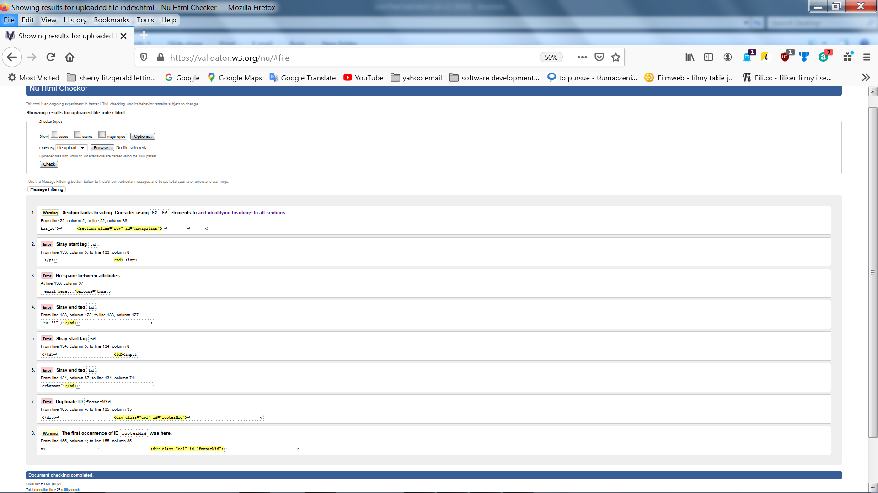

**TEST RESULT 1** Html validation index.html test 1

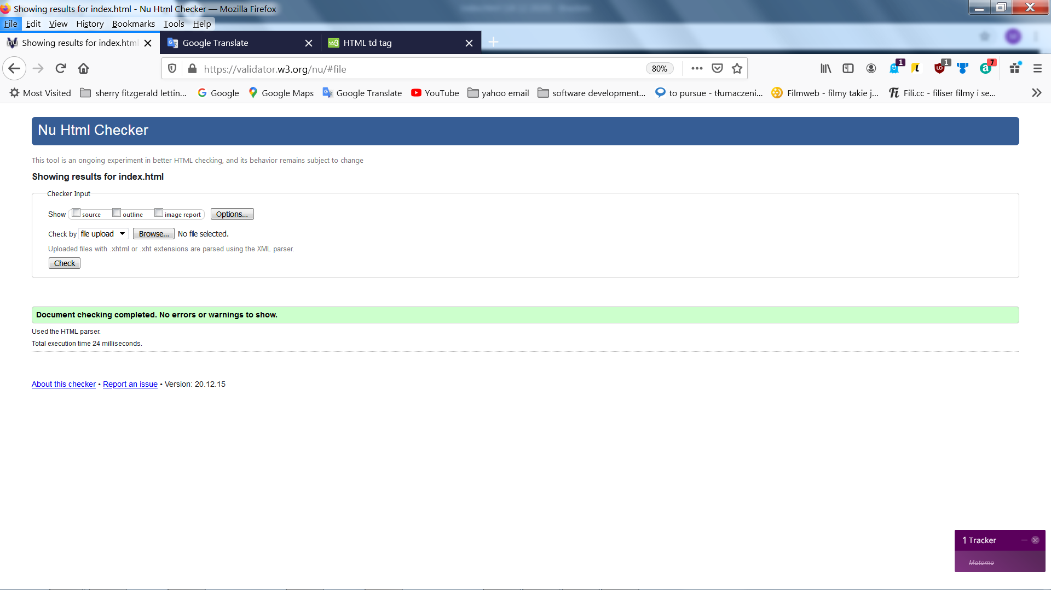

**TEST RESULT 2** Test 2 Index.html all error fixed

**Validation html on page about.html**

On this page errors were similar to the page index.html below photo with fixed errors.

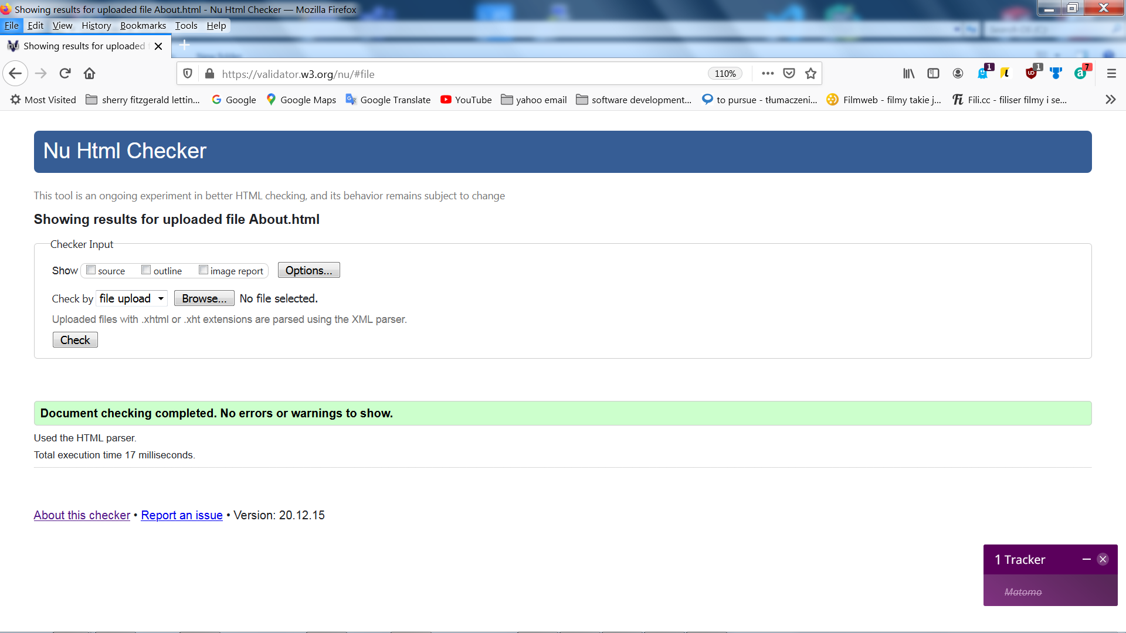

**Deployment 1** All error fixed on About.html

Validation html on page training.html, contact and Join to the club was few errors most common was that id was used twice, space and other small errors.

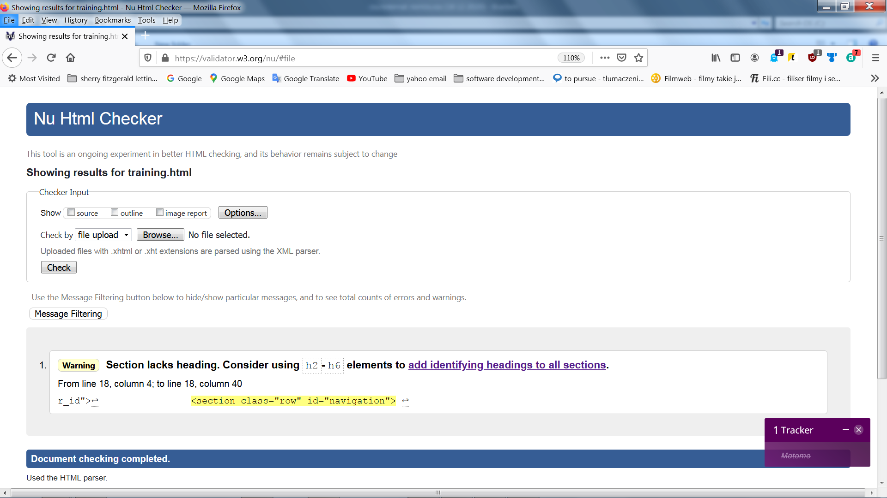

**TEST RESULT 3** One warrning on training.html

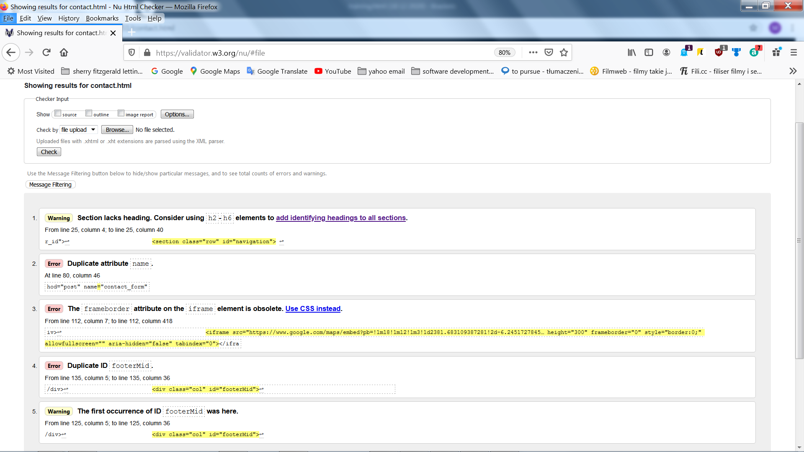

**TEST RESULT 4** Two warnings and 3 errors on contact.html

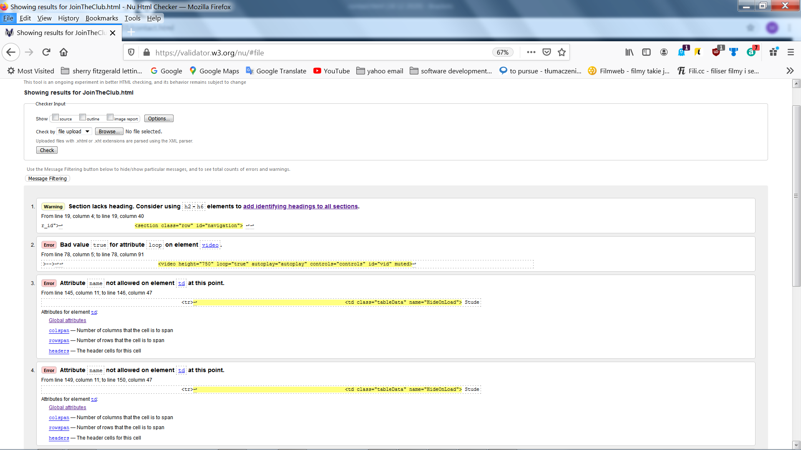

**TEST RESULT 5** One warnig and 4 errors on JoinTheClub.html

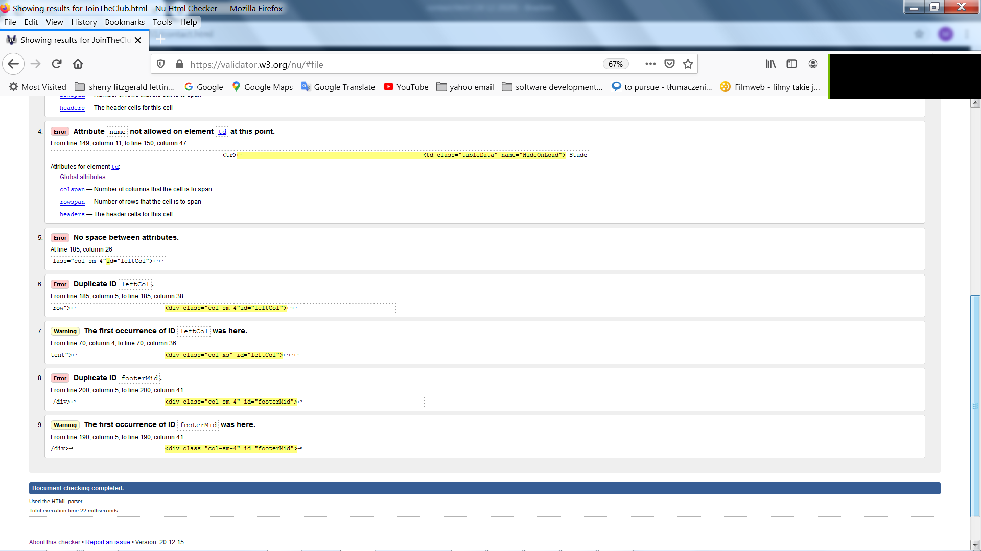

**TEST RESULT 6** Errors on JonTheClub page 2

**All errors were fixed and web site was ready for css test.**

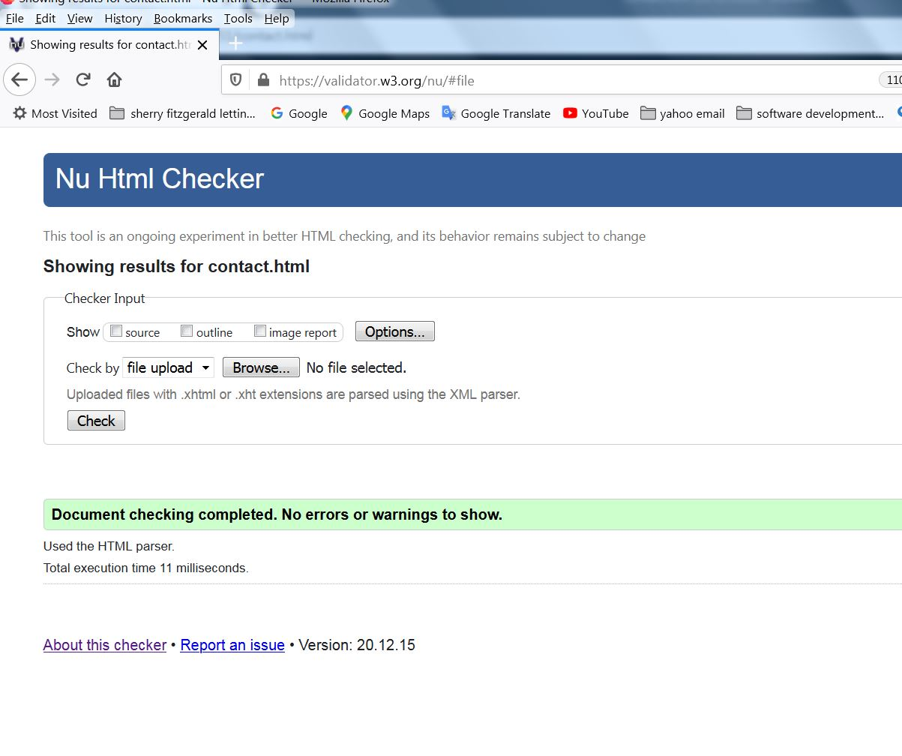

**TEST RESULT 7** All error fixed on contact.html

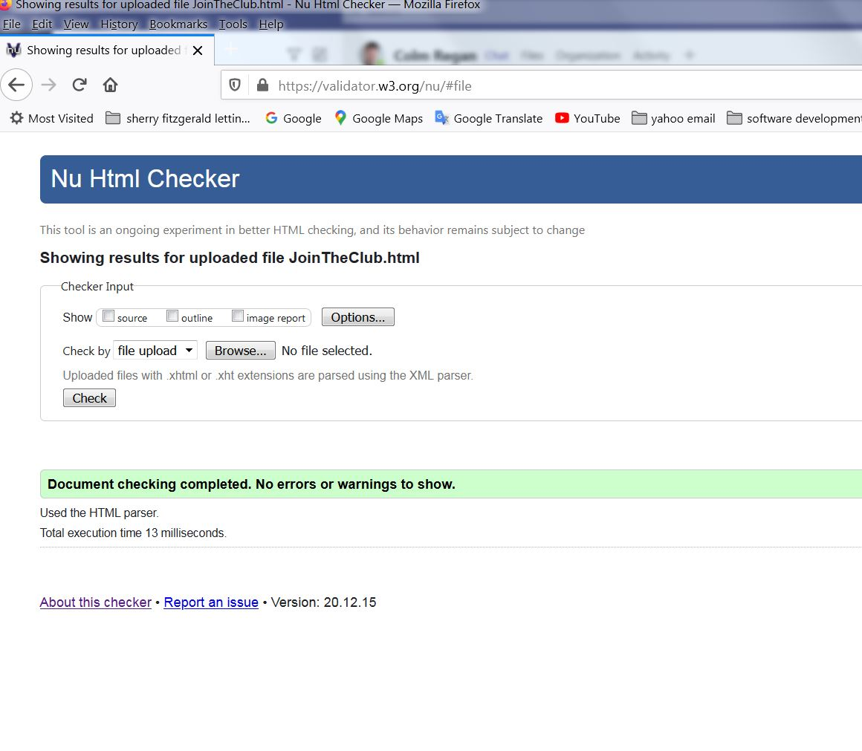

**TEST RESULT 8** All error fixed on JoinTheCLub.html

**Validation CSS.**

We had few errors in css in external-contact.css was to many closing bracket and border has no value clear, this line was deleted.

In the external-JoinUs.css file text decoration has no value Italic this line was deleted and max high has no value auto so whole line was deleted too. All css errors was fixed.

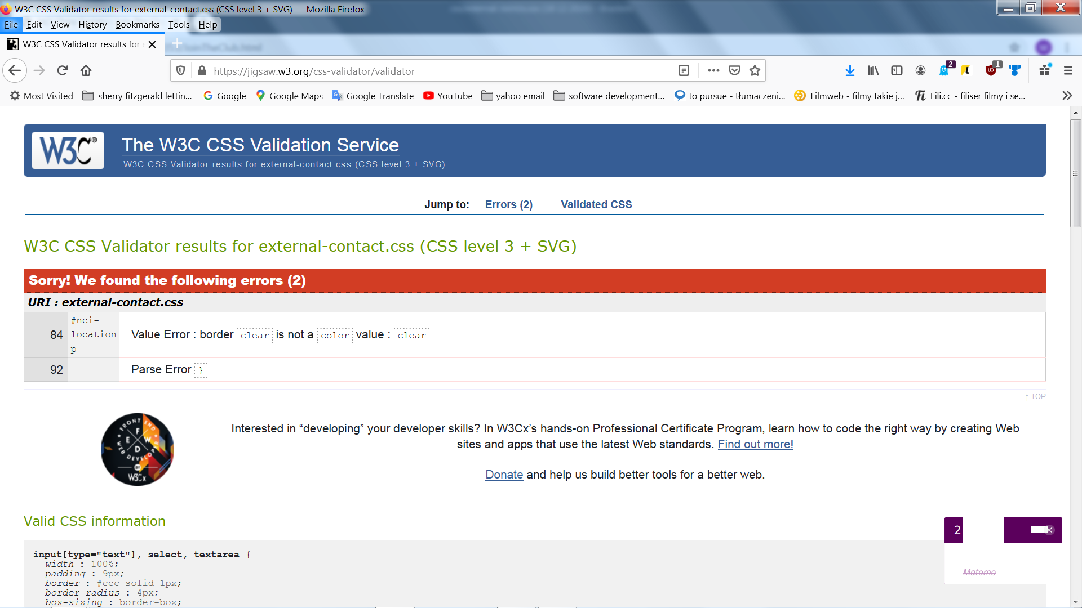

**TEST RESULT 9** Errors in external-contact.css

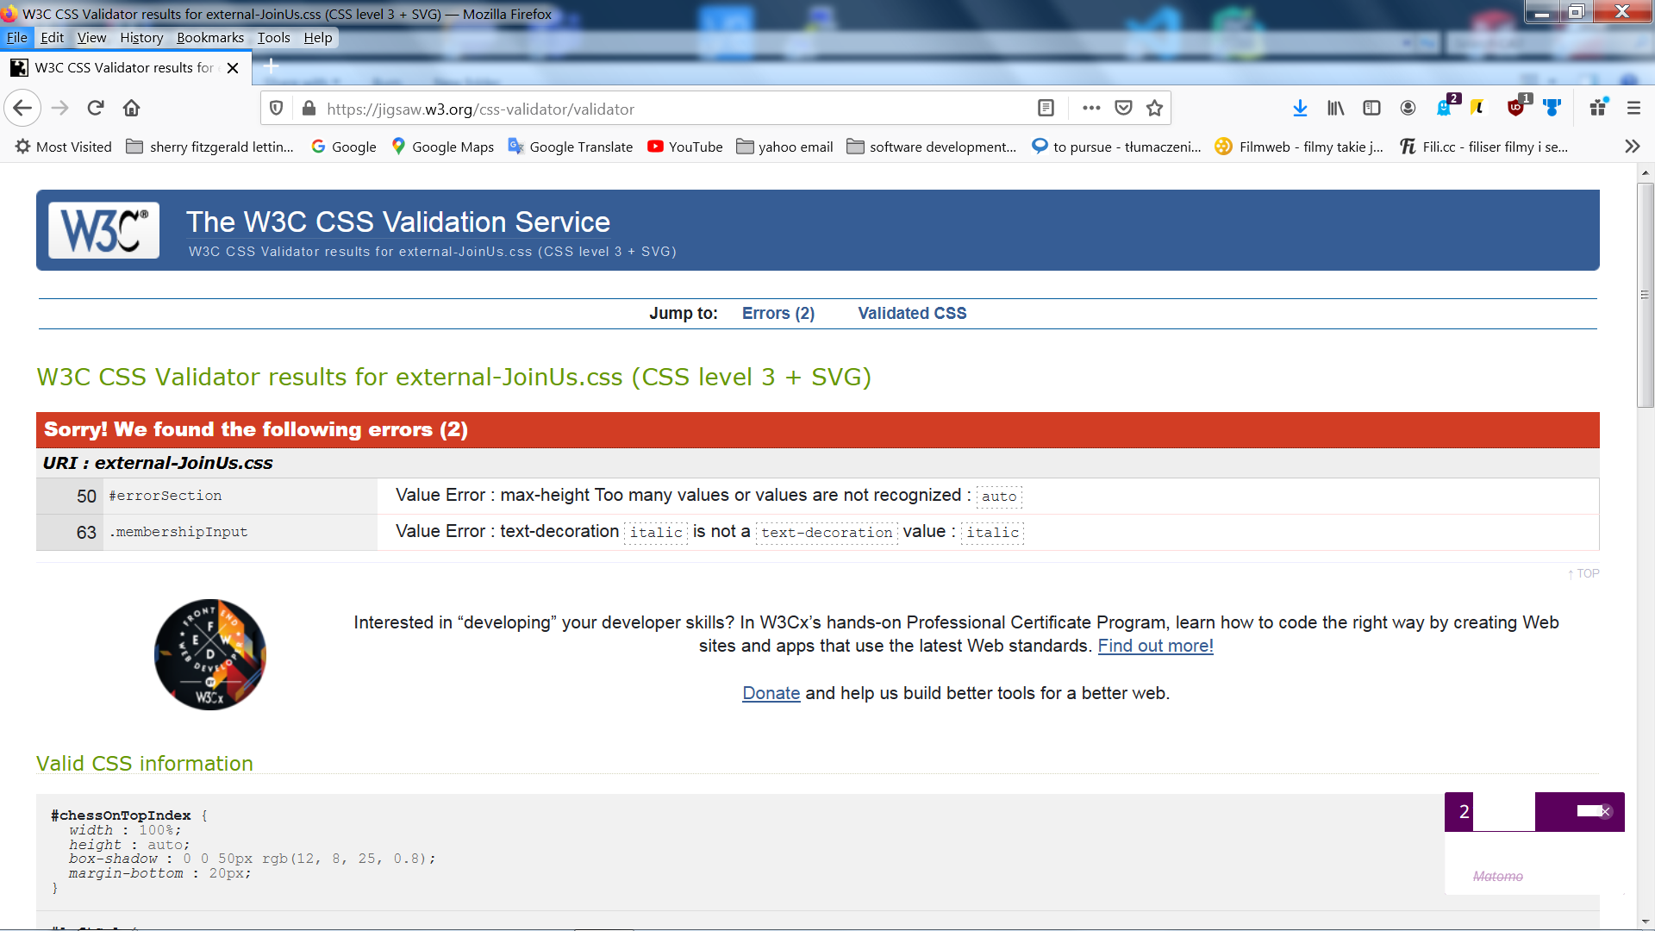

**TEST RESULT 10** Errors in external-JoinUs.css

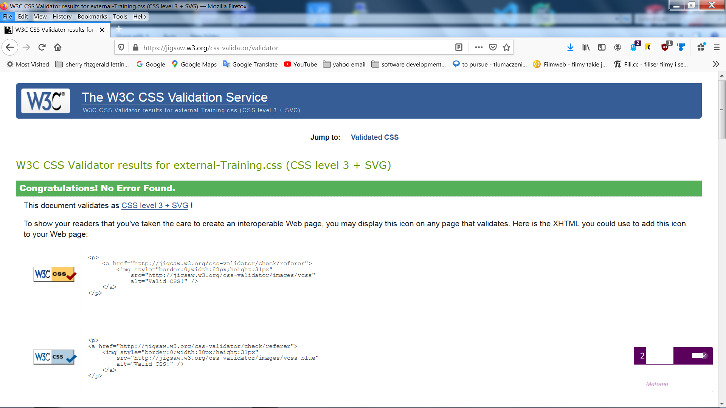

**TEST RESULT 11** No errors in external-Training.css

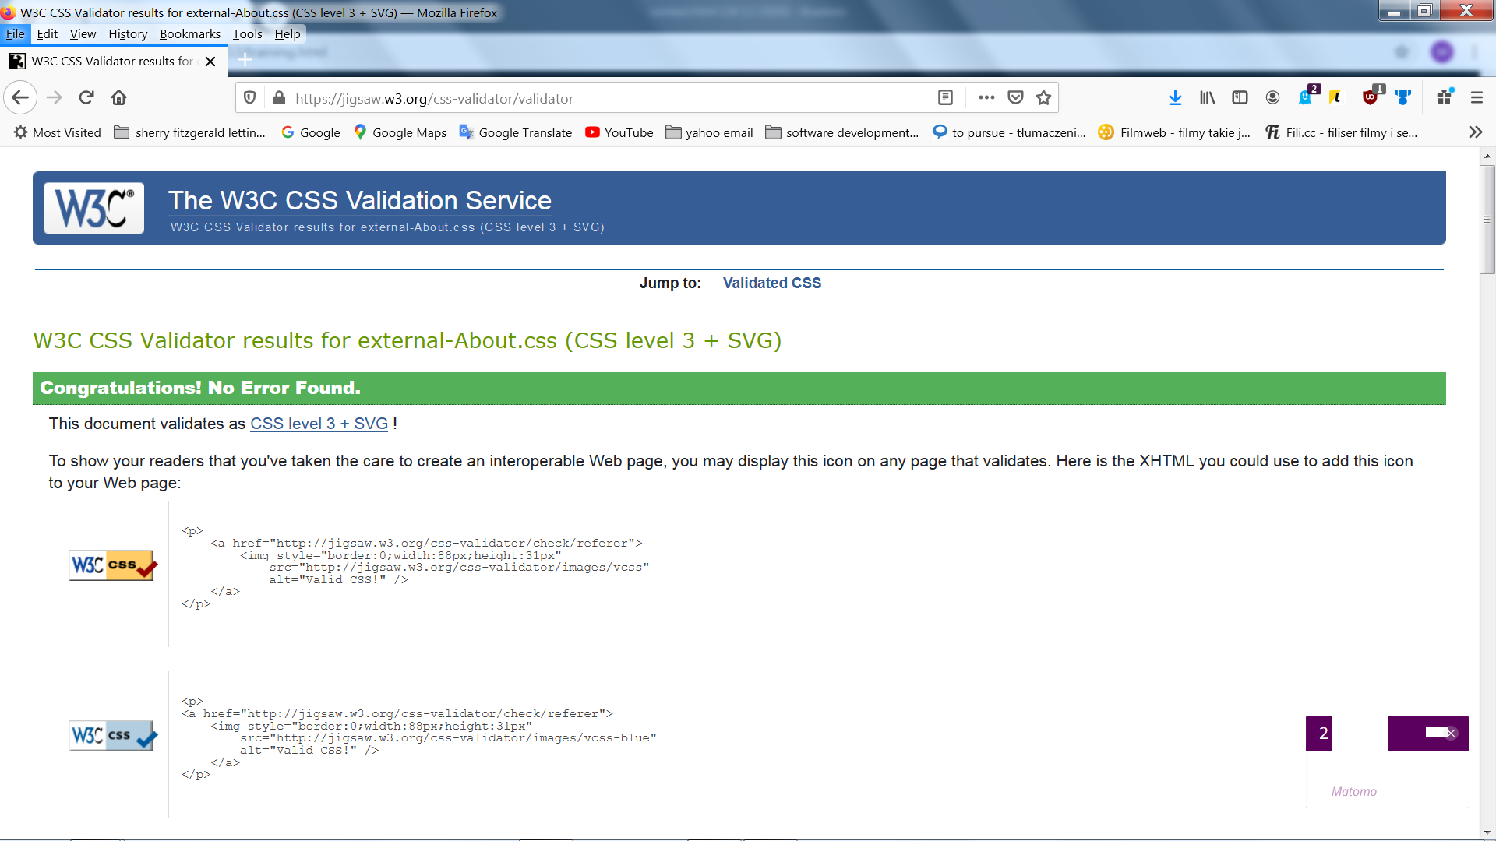

**TEST RESULT 12** No errors in external-About.css

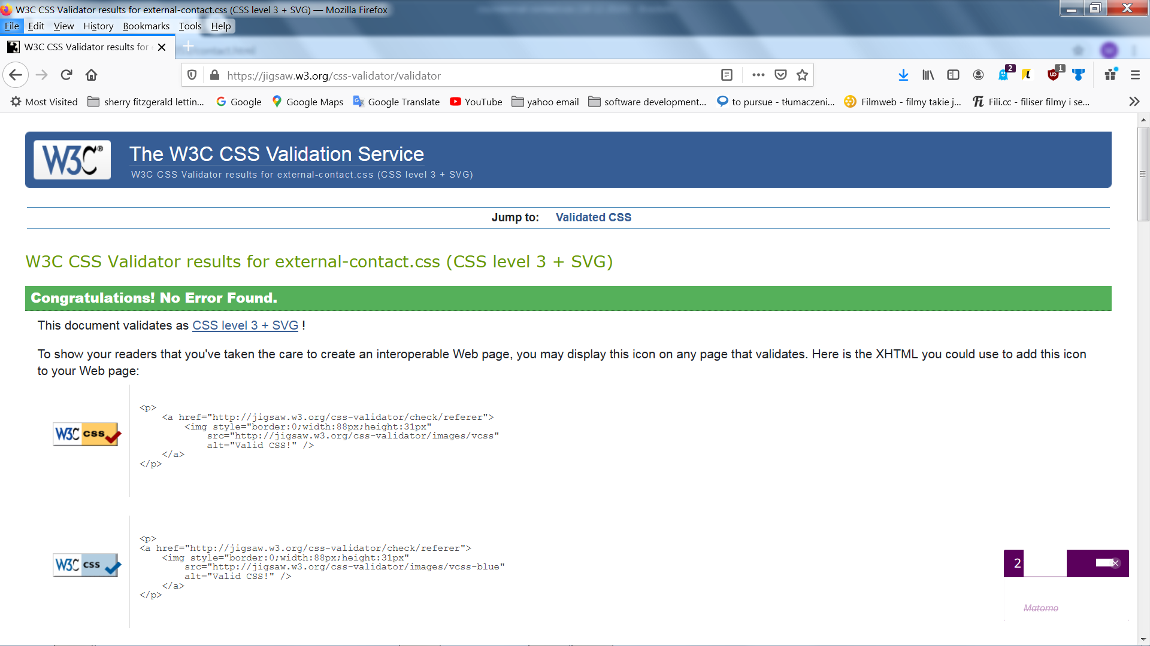

**TEST RESULT 13** No errors in external- contact.css

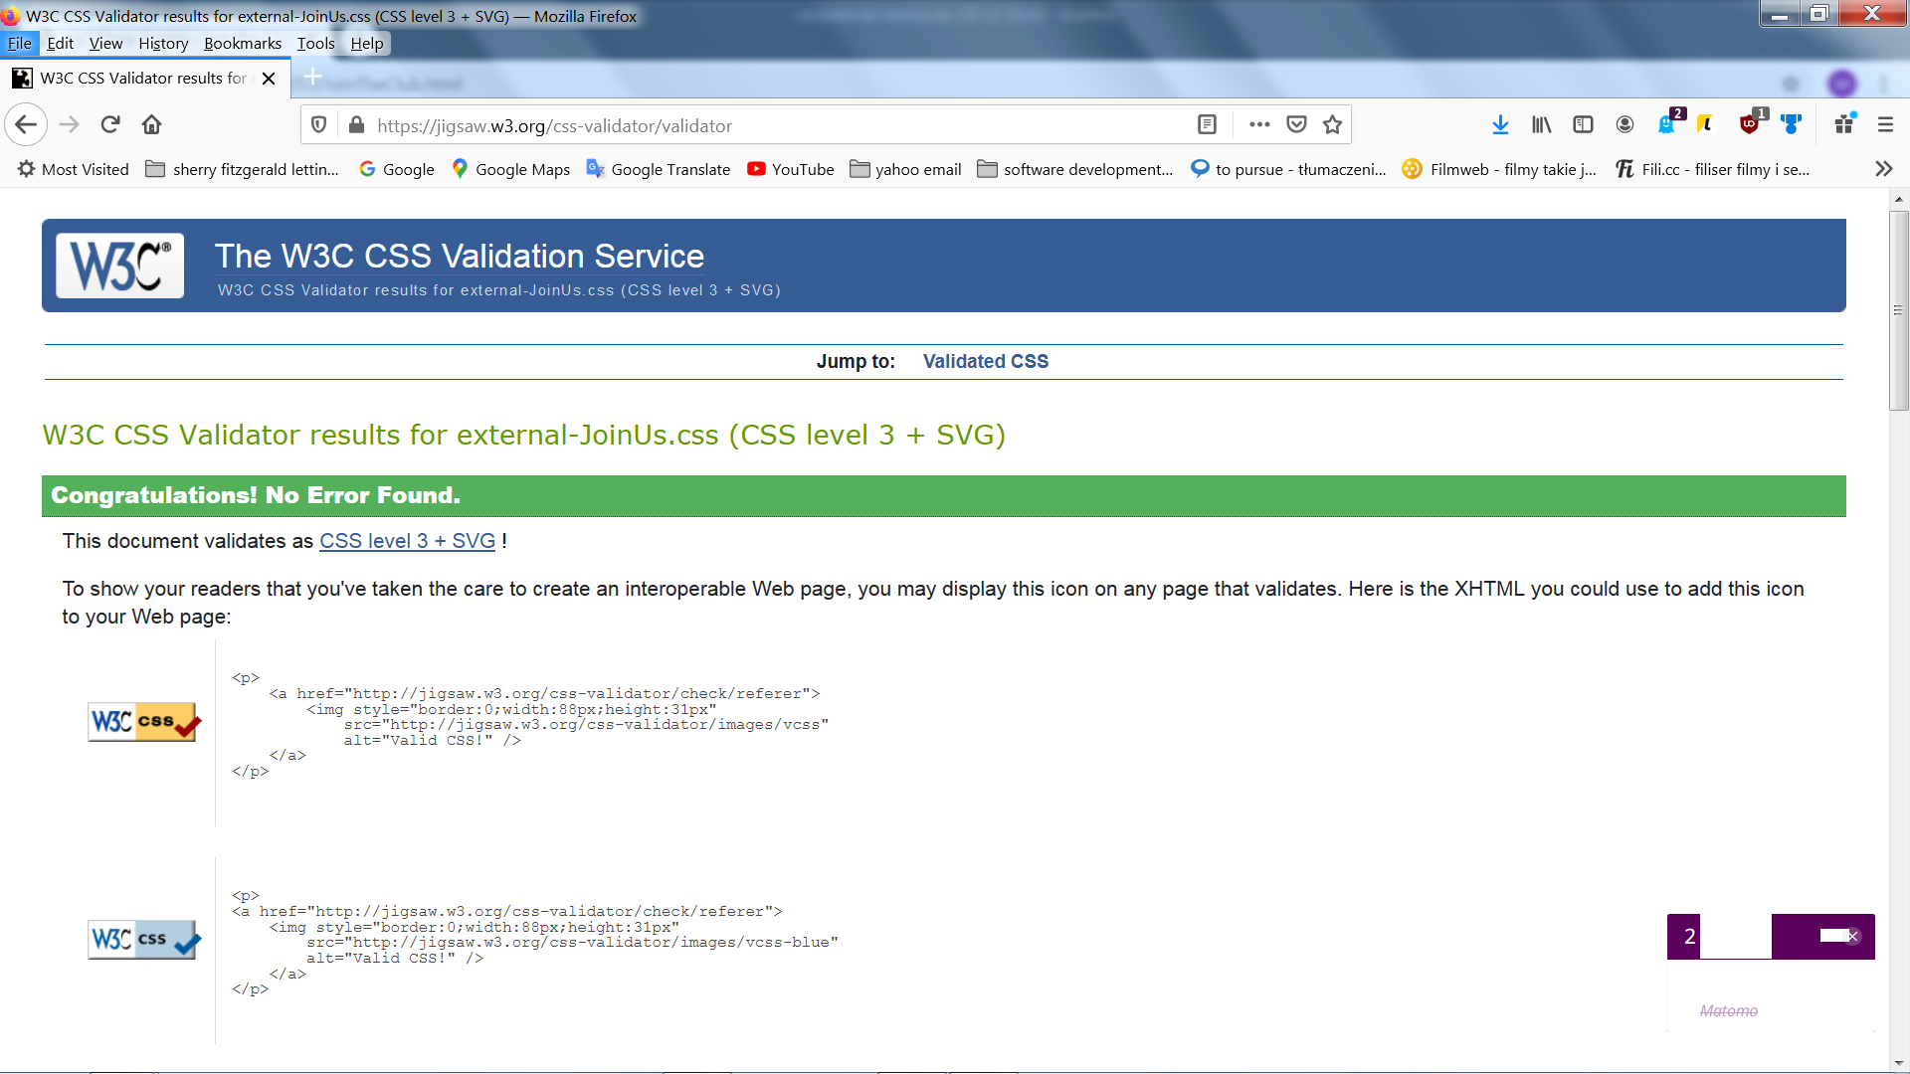

**TEST RESULT 14** No errors in external_JoinUs.css

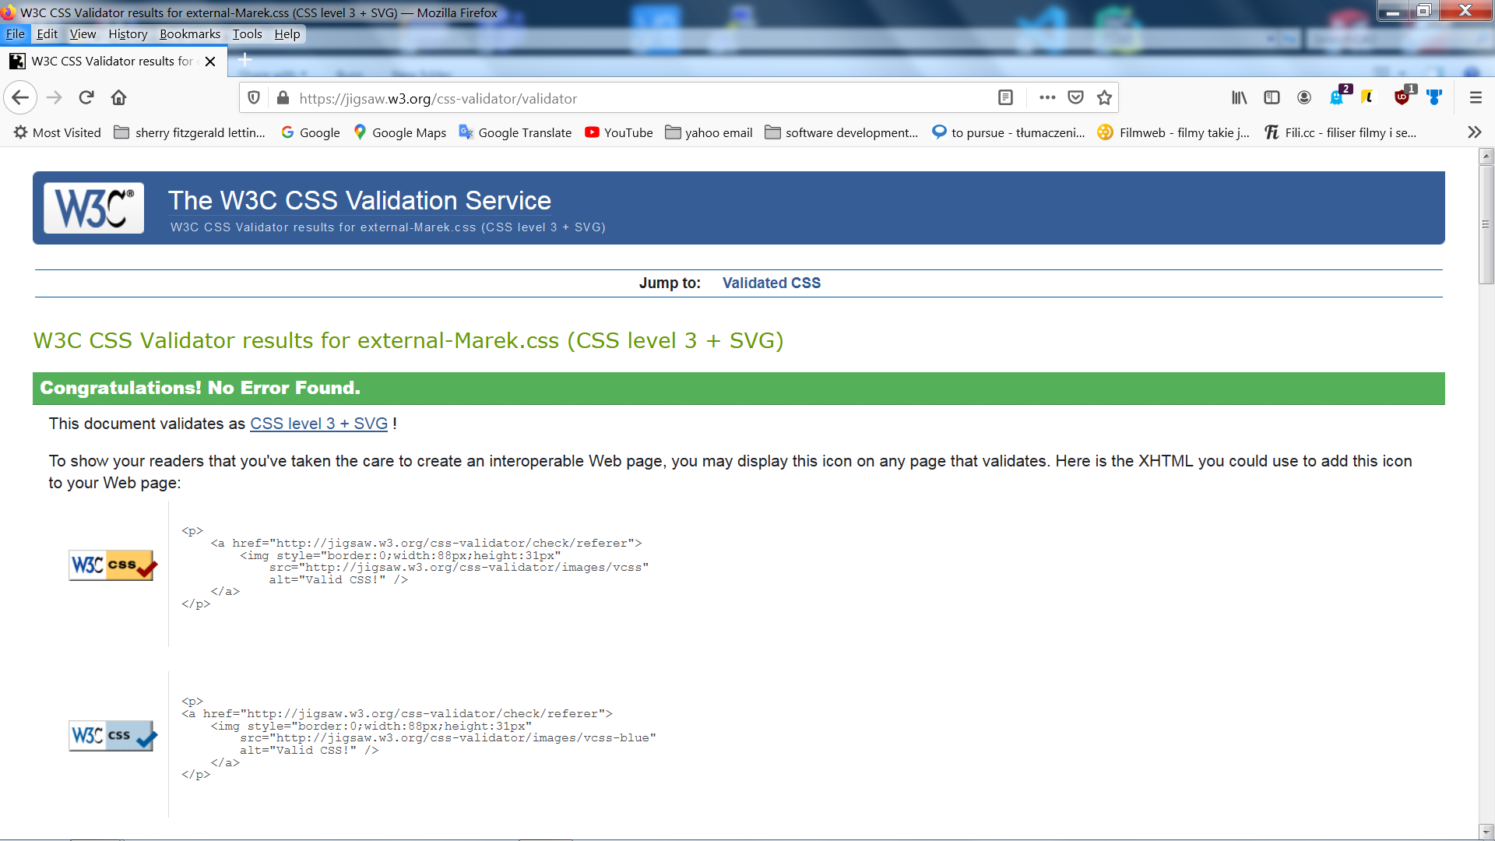

**TEST RESULT 15** No erron in external-marek.css

**Section 3: Deployment**

We agreed on Gearhost to be our deployment option. We went to the Gearhost homepage, created an account and named our server NCIChessSociety.

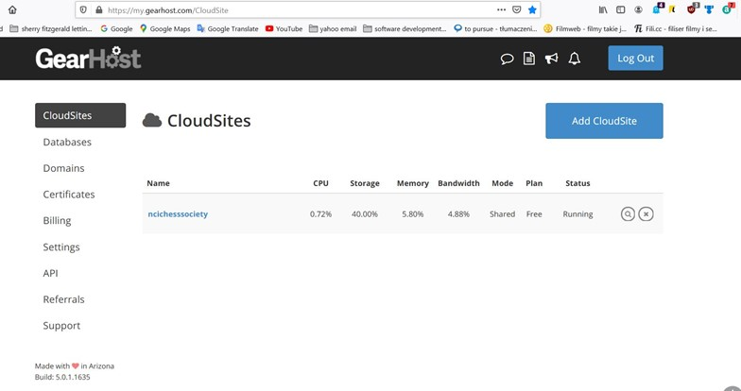

**Deployment 2** Creation account on GearHost

We then created a login and password field so that we could access the server.

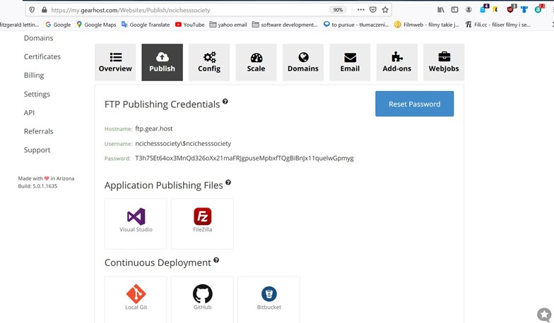

**Deployment 3** Gearhost server FTP detail

Then we uploaded files to root folder on the server using FTP on Total Commander.

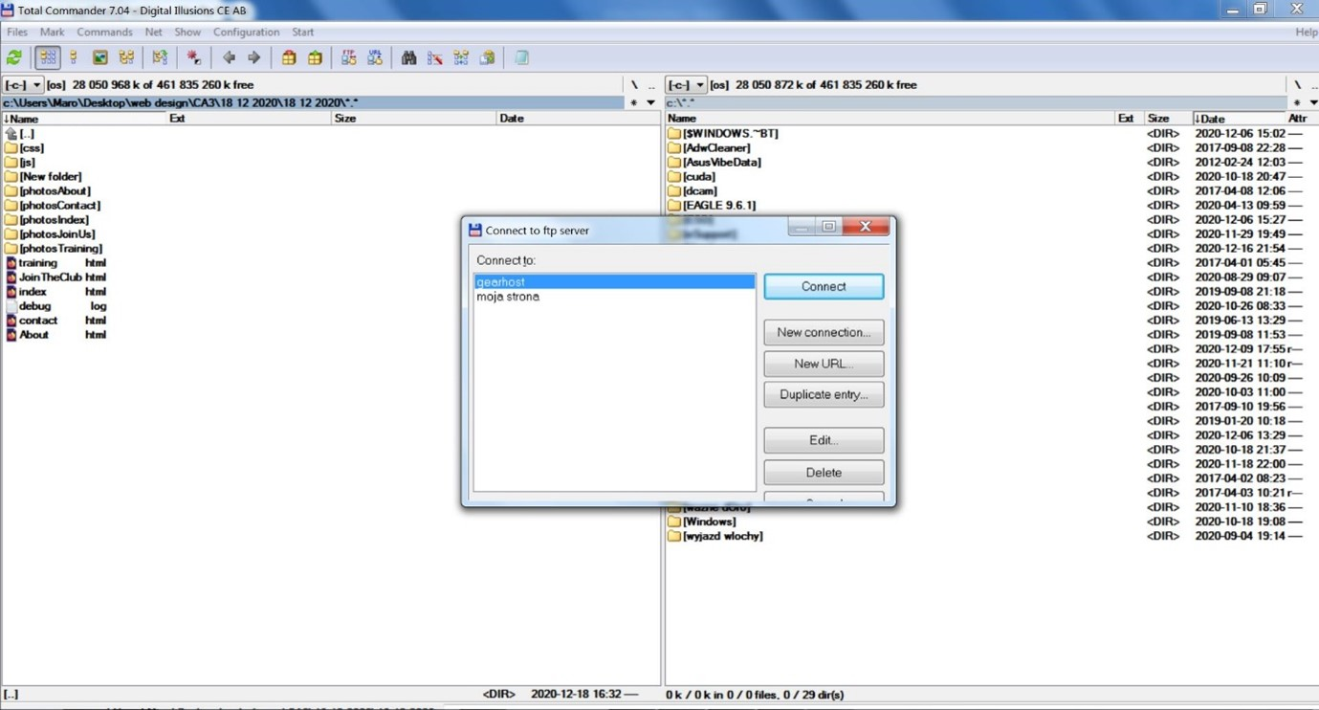

**Deployment 4** Uploading to the server content website

Once the website went live, we noticed that some things were not working correctly. After a series of testing we found that the video on our Join the Club page was not working properly. Upon review of this issue, we decided to change to the faster server.

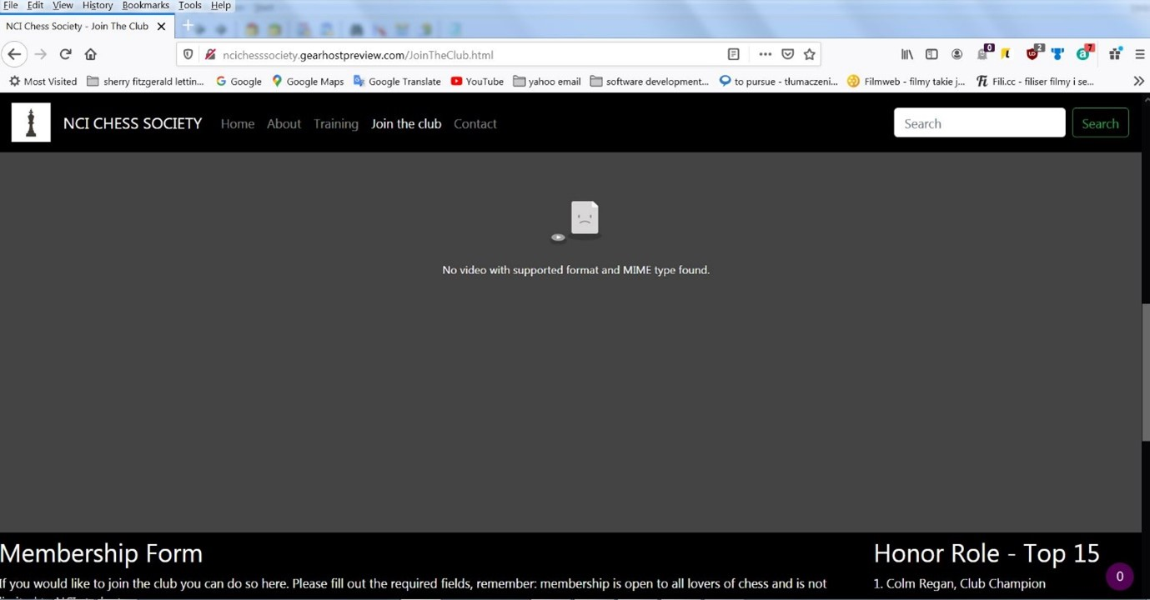

**Deployment 5** Error on the server gearhost.com

We decided to use limegreenlab.pl server because is was a good price and had positive reviews.

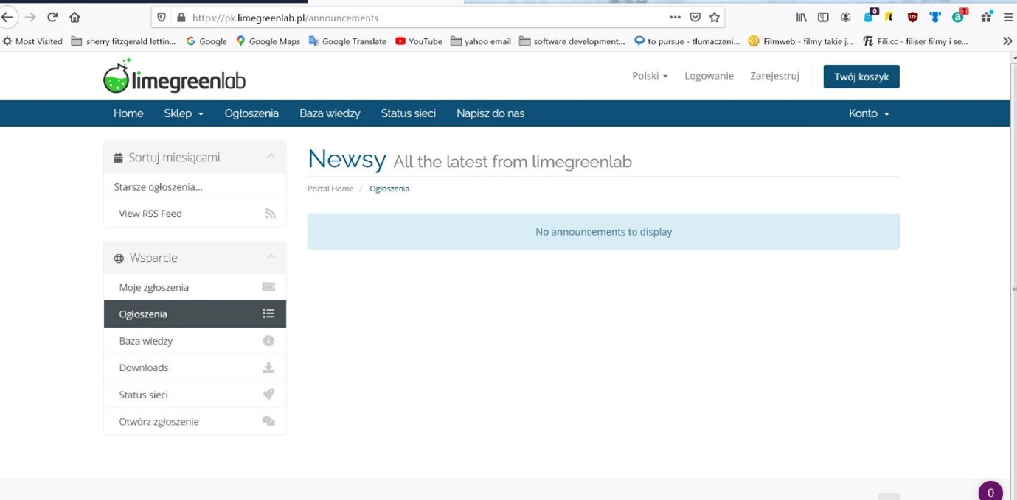

**Deployment 6** New Server were is located our page

We uploaded our website to this server using Total Commander and created the below name as an address:

NCI Chess Society website on life server: [**https://test.marekaugustyn.whshost.com/**](https://test.marekaugustyn.whshost.com/)

Below is a final image of the deployed site with all content working as it should.

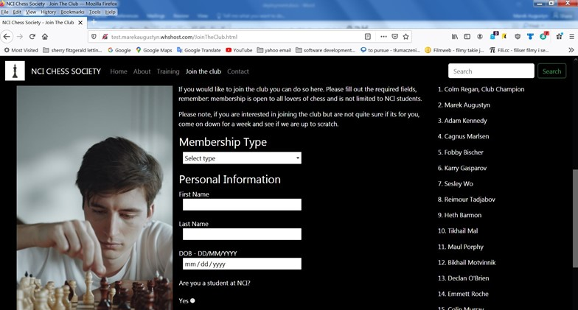

**Deployment 7** Live view NCI CHESS SOCIETY

**Section 4: User Testing**

Testing of the website was carried out by family members and friends. They were asked to perform testing tasks such as checking all links in the document to see if they are working correctly. They were also asked to check if an external link brings the user to the correct place. For form validation testing was performed by a Q&A tester who is a friend of one of the group members. By performing this test, a number of issues were raised with regards to the error messages that were being shown.

On testing the membership form on the Join the Club section of our website, testers were asked to fill in the form as if it was a real chess club. This was done to check how concise our questions were. From this test, we noticed a number of testers were incorrectly entering their date of birth according to the format we described. It was clear from this test that the format specifications for entering dates was incorrect. We decided to implement a real calendar where the user can simply just enter the day, month and year and let the website handle the rest.

Our form was a membership form to join the Chess club and asked the user for name and date of birth. if the user is under the age of 18, they will not be able to join the club. However, initially there was 1 error message which said “Please enter a valid date of birth”. The problem we discovered through this test was that there were 2 possible scenarios for an error to appear in the date of birth field. If the user left it blank and also if the user was under 18. We decided that we needed to change the error message depending on the nature of the error. By asking the user to enter a valid date of birth if they are under 18 wasn’t the correct message to show as the date of birth is still technically valid if they are under 18.

**Website Optimisation, Search Engine Optimisation and Testing.**

Website was tested on different browsers, we were using Firefox, Chrome and Safari and also mobile phone Samsung Galaxy S8 with chrome browser for mobile version and desktop. We realize that responsiveness is good. Pictures and text is visible but is one issue what we couldn’t feed that navbar is all the time in the version like for mobile phone even if we change to desktop view. It is not a big problem because navigation menu on the website is still very good to operate.

After deployment we manual testing we make a speed test using online tools like [www.webpagetest.org](http://www.webpagetest.org) and https://gtmetrix.com/ . They show us our speed and weak point in our site.

Customers doesn’t like wait until page is loaded so we decided that if a page will be loading longer than 3 seconds then we need to do optimization. On the screen below you can find that according to gtmetrix test that performance grade is C (A is the best) and loading time is 2s. Result is good but could be better after deeper analysis of the test result we realized that we can decrease loading time if we compress images. In our project we were using photos approximation 300kb so we should decrease size to about 100kb. We confirmed this fact with another test on webpagetest.org – compress image rating F(A is the best) . We decided to keep a page like it is but we should use compressor to change a weight of the file if we want to improve loading speed.

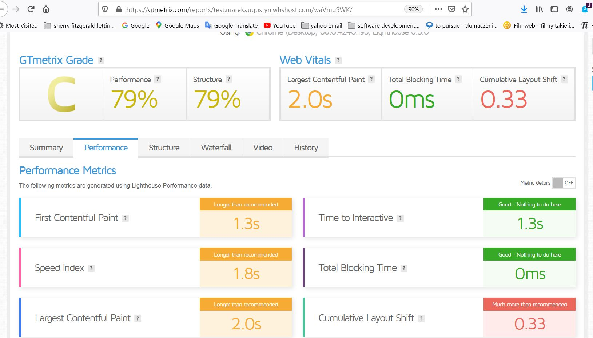

**TEST RESULT 16** From https://gtmetrix.com/ performance grade C (79%)

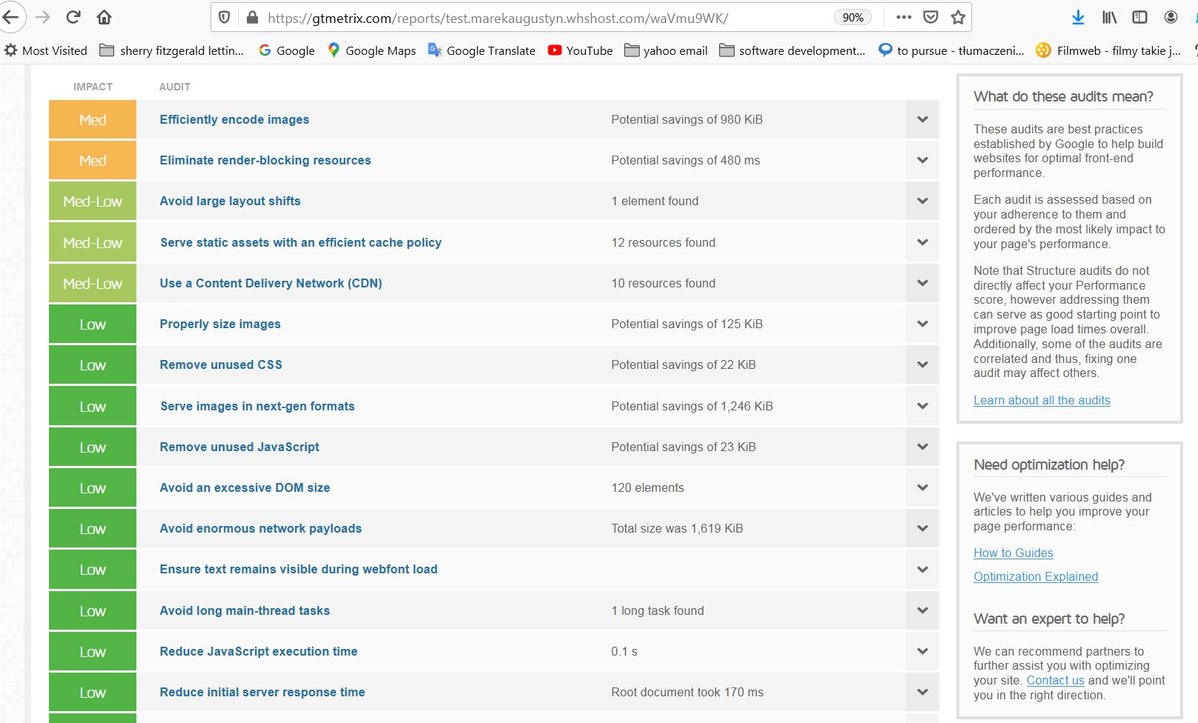

**TEST RESULT 17** Efiiciently encode Image is medium

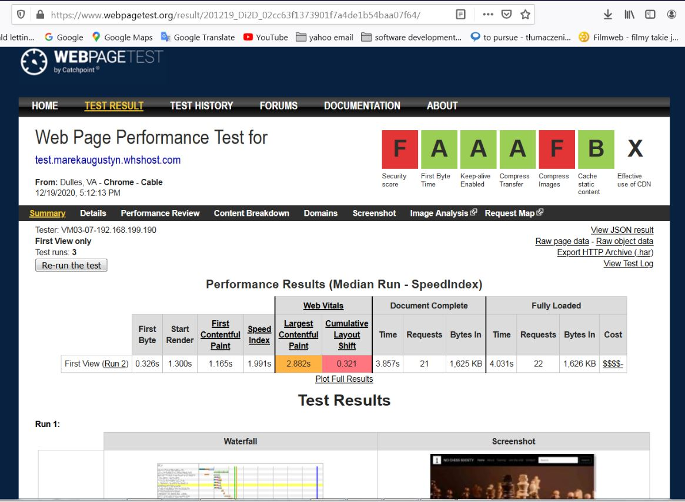

**TEST RESULT 18** Webpagetest.org Image commpress rating F

**Search Engine Optimisation. (SEO)**

1. On Page SEO.

To on page SEO we had to find keywords which we put into our webpages in head and metatags.

To find the best keyword we were using website wordsteram.com it is a page where you can search a most common word that people were search in the are interested to us.

We were search for the “chess club” and “chess” in Dublin, Ireland, on the page app.wordstream.com.

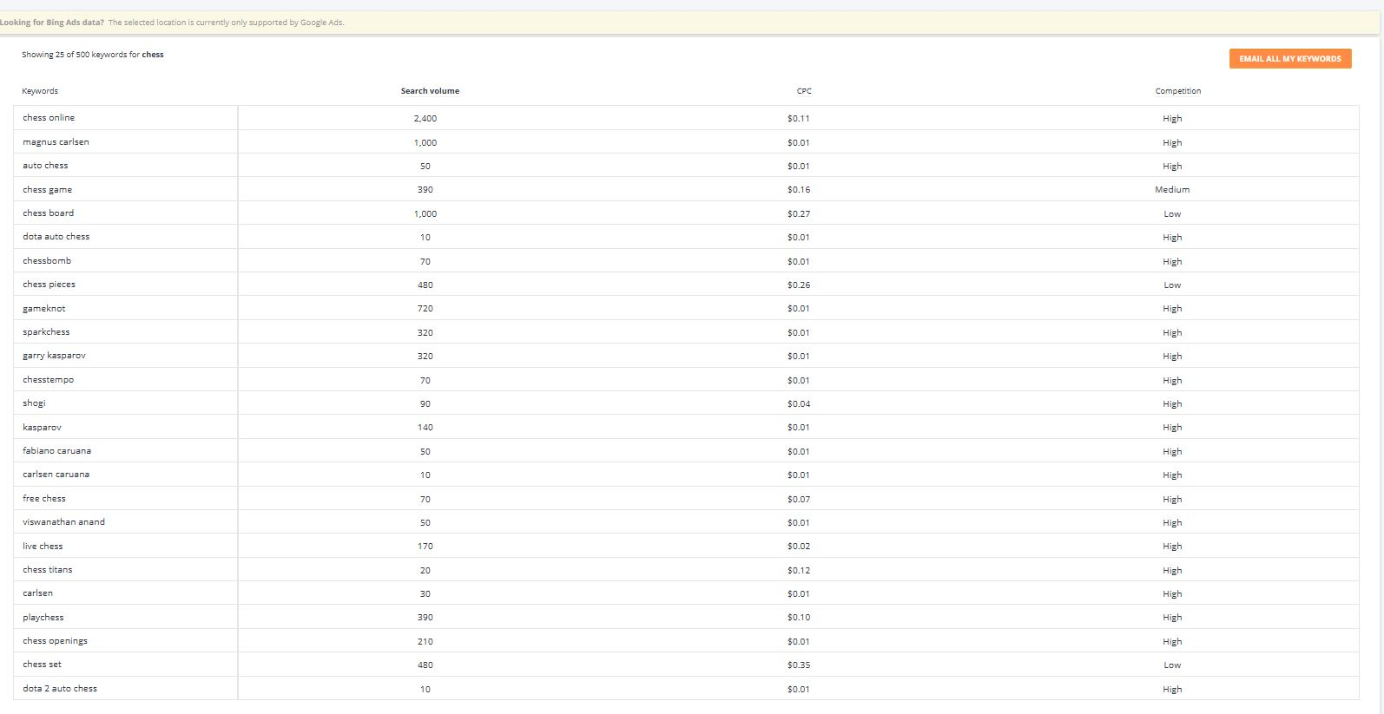

**TEST RESULT 19** Search result for word chess on wordstream.com

We saw that for search keyword “chess club” we had: club chess near me, chess league, the chess club

For search “chess” we had word like: chess online, magnus carlsen, chess board, garry kasparov, play chess, chess set.

We put this key-words to our website in metatag , heads and alt in the texts inside the whole page.

To full optimisation we should buy domain with the name like ncichesssociaty.ie

or ncichessclub.ie after research we think that better name for our site probably is NCI chess club because the chess club has a bigger amount of search in area and ncichesssociety in the name seems be to many “sss” so chessclub looks better. We did not buy domain because lack of time, for registration and activation new domain we need more than just couple of days. In this case we could not to full SEO because lack of full Deployment.

**Section 5: Project Team**

Task were broken up according to our own individual strengths and weaknesses. Group members volunteered to take on whatever aspects of the website they were comfortably with.

**Colm Regan**

* Colm provided the initial wireframes and sitemaps of the entire website.
* Created the layout for all 5 pages with this initial layout plan.
* Was responsible for creating the Join Us page as well as writing all the JavaScript for the member form.
* Wrote the jQuery for the homepage and about page, which validates a person's email address when signing up for the newsletter.
* wrote this entire report except for the deployment section and validation errors.

**Marek Augustyn**

* Marek provided the update to all 5 pages of the site and incorporated Bootstrap to deal with the responsiveness.
* Created the final layout of all 5 pages of the site.
* He was also responsible for deployment, and the deployment section of the report.
* Optimisations and testing of the website.
* Created the Contact us with java script validation contact form page and the cookies section.
* Updated footers
* Validated the website and fixed errors

**Adam Kennedy**

* Adam wrote the content for the About page.

Everyone did not participate evenly in this project; however no issues were raised. It is very much a learning experience so Colm and Marek had no problem working hard to create this website and report.

**Section 6: Conclusion**

In conclusion, we left that this a very enjoyable project which had many useful learning outcomes. We achieved everything we had initially planned, however, given a bit more time we would definitely implement a puzzles section to the website. Here, users would be presented with an array of images, each one displaying a different scenario. They would then be asked to see if they can checkmate their opponent in 4 or so moves. This concept was a part of our initial plan however after a review of workload and concise validation needed to achieve it, the idea was unfortunately abandoned.

We were very happy with the results and believe that we have created a very elegant and content rich website.

**Section 7: References / Appendix**

Stanborough, R.J. (2020). *The 10 Best Benefits of Playing Chess.* Available: https://www.healthline.com/health/benefits-of-playing-chess. Last accessed 15/12/2020.

Aldersons Broaddus University (2020). *Common Issues for College Students.* Available: https://ab.edu/counseling-services/common-issues-for-college-students/. Last accessed 15/12/2020.

Dublin Chess Club. (n.d). *Welcome to the Dublin Chess Club.* Available: http://www.dublinchessclub.com/#. Last accessed 15/12/2020.

The Chess Website. (2020). *Learn, Practice and Play Chess..* Available: https://www.thechesswebsite.com/. Last accessed 15/12/2020.

Mialki, S. (2020). *How to Use the F-Pattern to Increase Conversions.* Available: https://instapage.com/blog/f-pattern-layout. Last accessed 16/12/2020.

Rathmines Chess Club. (n.d). *Roll of Honor.* Available: https://rathmineschessclub.wordpress.com/club-champions-1939-present/. Last accessed 18/12/2020.